Bittium Faros 360

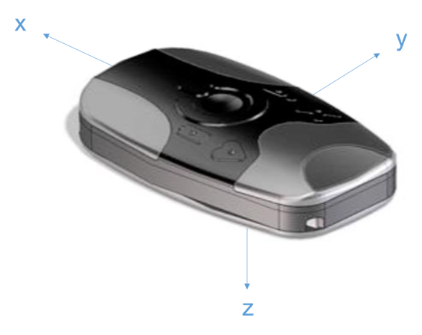

Vertical orientation – USB port is superior

x+ is superior

y+ is left

z+ is posterior (toward skin)

Horizontal orientation

x+ is right

y+ is superior

z+ is posterior (toward skin)

Axivity AX6

Lateral Ankle - USB port inferior, text on skin

x+ is proximal

y+ is anterior on left ankle, posterior on right ankle

z+ is lateral (away from skin)

Dorsal Wrist - USB port radial (thumb), text on skin

x+ is ulnar (pinky)

y+ is proximal on left wrist, distal on right wrist

z+ is dorsal (away from skin)

GENEActiv Original

Lateral Ankle - contact pins inferior

x+ is anterior on right ankle, posterior on left ankle

y+ is distal

z+ is medial (toward skin)

Dorsal Wrist - serial number readable to wearer

x+ is ulnar (pinky)

y+ is proximal on right wrist, distal on left wrist

z+ is palmar (toward skin)